**Grid and Table Tasks**

1. **Write a script to create four sections having table coulmn enter random data in table that data should have font size in rem unit. Shrink the width of table to observe the responsive image all four table should be display vertically on sm device(try various class of table).**

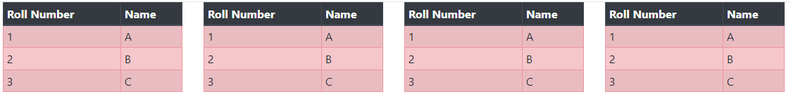

1. **Write a script to create two sections having table column enter random data in table that data should have font size in rem unit. Shrink the width of table to observe the responsive image of all tables should be display vertically on sm device, compulsory using classes of tables.**

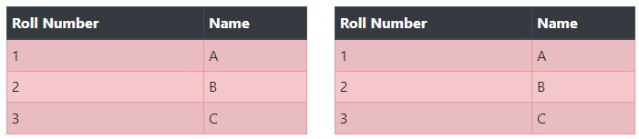

1. **Write html/css script using bootstrap to take four sections using div. first section has text related componets like paragarph abbr and pre tag.second section has a table having three rows first is lowercase , second upeercase and third capitalize. third div has simple direct case in justify manner and last div has blockquote all div width are 25%.**

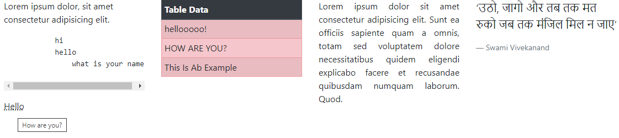

1. **Write a script to create four sections having table coulmn. Enter random data in table. Table should have different color classes for different rows. Shrink the width of table to observe the responsive image all four table should be display vertically on sm device(try various class of table).**

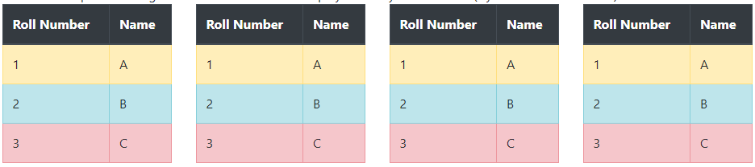

1. **Write HTML/CSS script using bootstrap to set four images of some product horizontally and show their price, features and available quantity in grid system, responsive effect must be observed.**
2. **Write html/css script using bootstrap to take two sections using div. Use any three typography classes in 1st section. Second section has a table. Observe responsive concepts and use table oriented classes in 2nd section.**
3. **Write html/css script using bootstrap to create three sections using div tag first section as heading and second section as its description and third section has respective links to search that image. Show responsive web page concepts.**
4. **Write bootstrap script to have two sections of image and image description, left div description and right div should have photo. give appropriate partition classes and observe responsive concepts.**
5. **Write html/css script using bootstrap to create two sections using div tag first section as heading and second section as its description. Heading should be center align and description should be left align in that section includes responsive web page concepts.**
6. **Design one web-page for “online-shopping of beauty products”. Use Bootstrap concept for display images of different beauty products in proper alignment.**

**Accordion Tasks**

1. **Write an HTML script using bootstrap to design a page of newspaper having three articles by showing only titles initially. Script should enable a render to open a particular article viewing and clicking its title and close it by clicking it again. If render opens any other article, then previous article should disappear.**
2. **Write an HTML script using bootstrap to design a page of essay having three titles by showing only titles initially. Script should enable a render to open a particular essay by viewing and clicking its title and close it by clicking it again.if render opens any other title then previous title should disappear.**

**Progress bar Tasks**

1. **Write a script using HTML/CSS using Bootstrap to create two sections of 30% and 70% width. First section has parameters with different color indications and show progress-bar in specific color only with random progress.**
2. **Write a script using HTML/CSS an bootstrap to create two section 30% and 70% width. First section has parameters with different color indications and show progress-bar in specific color only with random progress. All progress bars should have animated effects.**

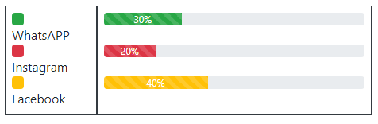

**Collapse**

**Write bootstrap to create a simple collapse button and open/close one section of paragraph by clicking that button.**